# Fitness Tracker Web API

GitHub repository URI: <https://github.com/craig19/WebAPIFitnessTracker>

Swagger Endpoint: <http://fitnessapi-dev.eu-west-1.elasticbeanstalk.com/swagger/>

The Fitness Tracker Web API was setup to serve an Android app and its users, their details and their personal workout/exercise details.

The API allows the Android client to:

* Get/add/update/delete app Users and Users personal data (which will be done from a User Profile activity on the Android app). These details include First and Second Names, Age, Weight in KG and Height in CM.

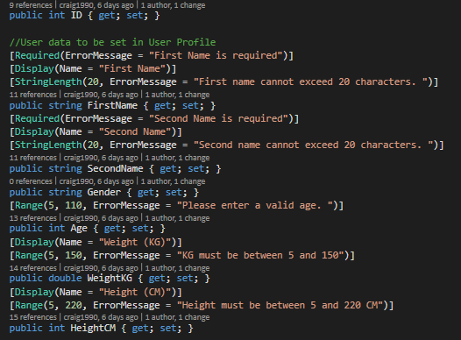

* Get a User’s Basal Metabolic Rate (BMR) from the User’s age, weight and height data, which is stored in the database. BMR is the number of calories required to keep your body functioning at rest; closely related to your body’s metabolism.

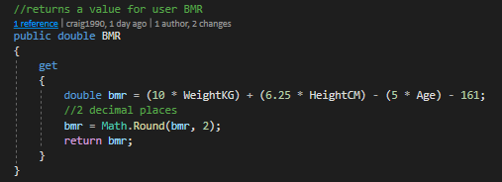

* Get a User’s Body Mass Index (BMI) from the User’s weight and height data which is stored in the database. BMI is a value derived from your weight and height to determine if you are a healthy weight e.g. what category you belong in: severely underweight, underweight, normal, overweight, obese.

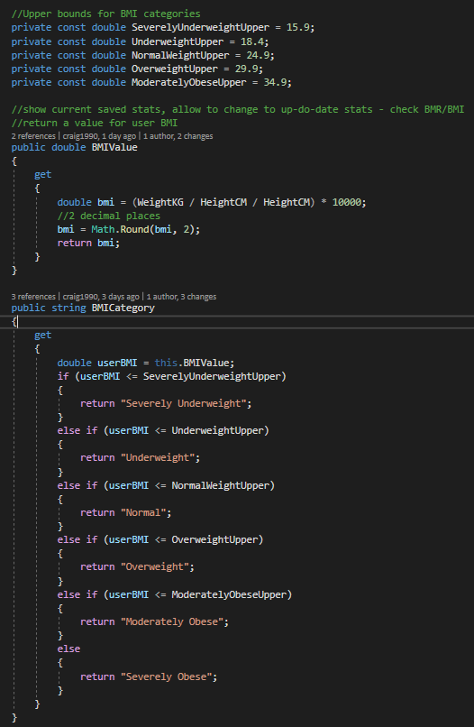

* Add a User’s personal workouts to their workout list; a workout includes data such as date of workout, workout duration, calories burned during the workout (easily attainable nowadays from smart watches), and workout details (exercises completed etc.). This will allow the app to show a list of a User’s past workouts to them, to allow User’s to track their time working out, their calories burned working out and also keep track of their workout details such as body parts worked on and exercises completed etc.

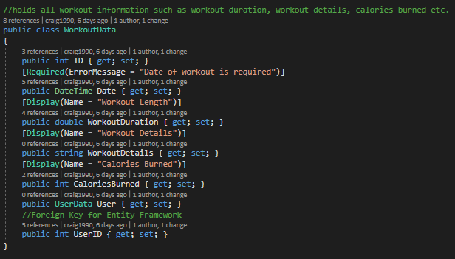

* Get a User’s workout duration and calorie statistics e.g. total calories burned over the last 7 and 30 days and total time working out over the last 7 and 30 days, longest workout of the month.

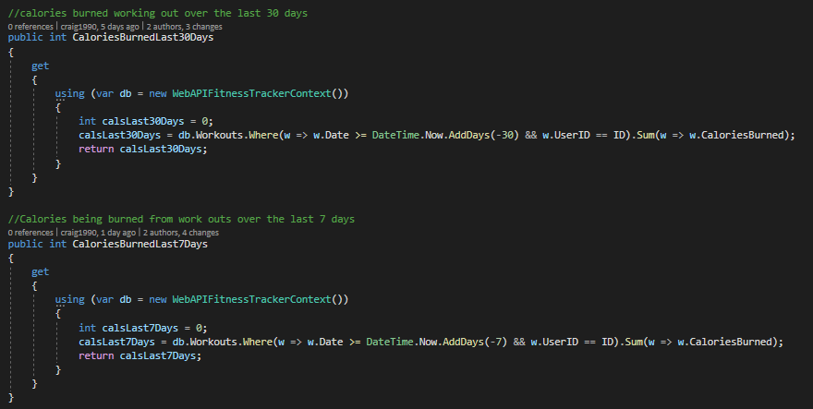

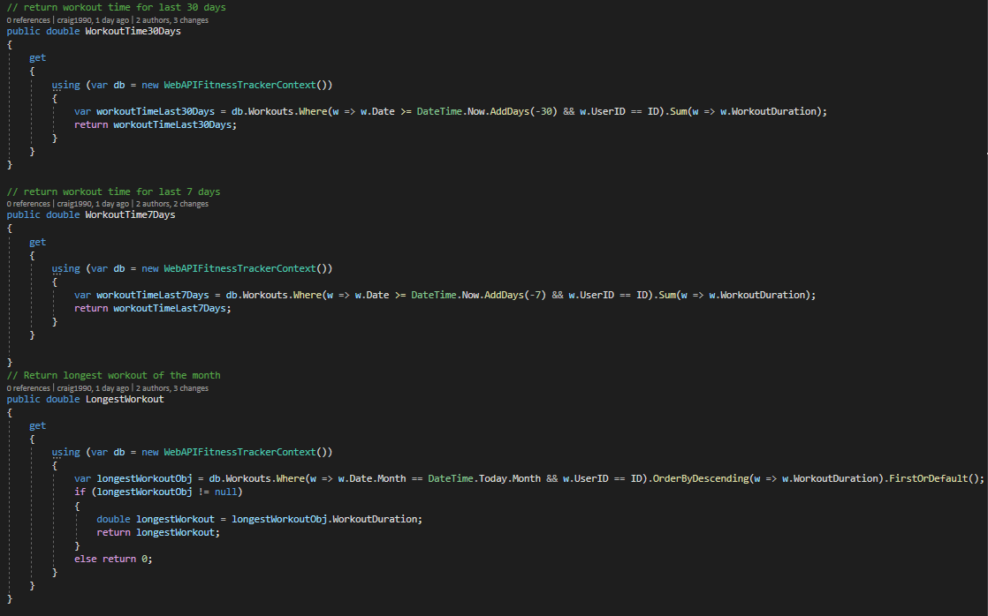

The Swagger page showing all API endpoints to facilitate the above. The project video shows a running Swagger test; adding a user with initial details, adding workouts to the users list of workouts and getting that users details back including all additional stats such as BMR, BMI and calorie/workout length stats.

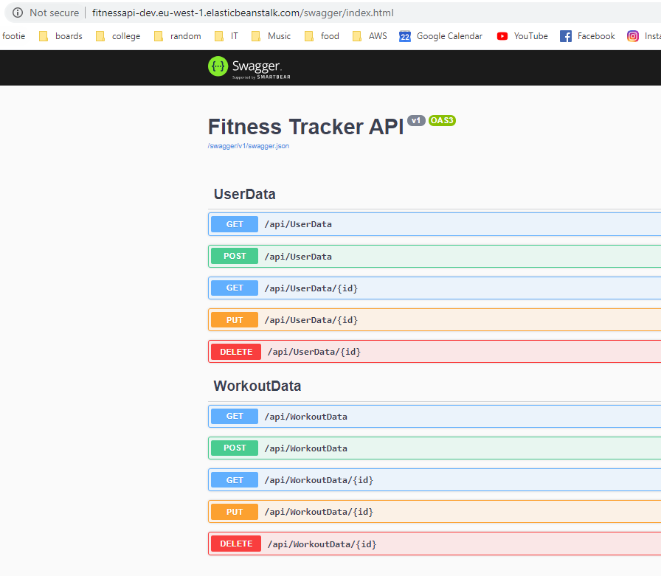

A full User object

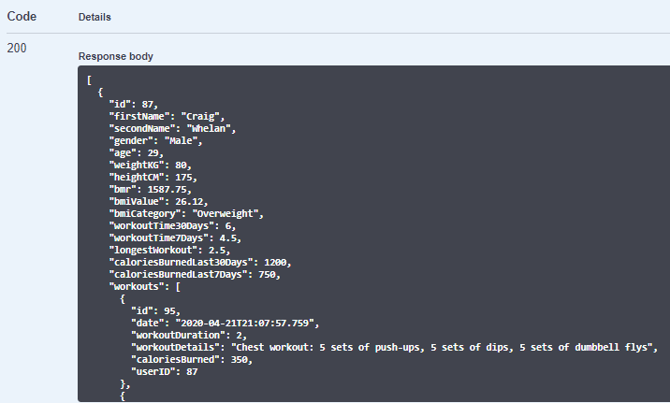

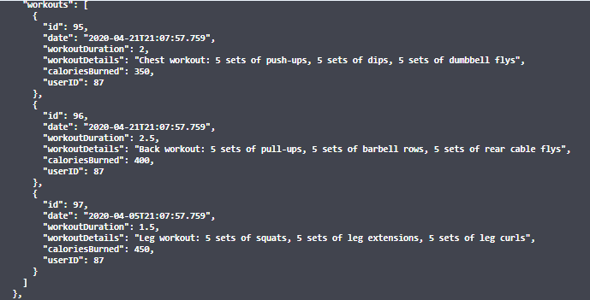

2 database tables 1 for Users and one for Workouts. A user has a list of workouts and entity framework uses userID as foreign key for map workouts to users.

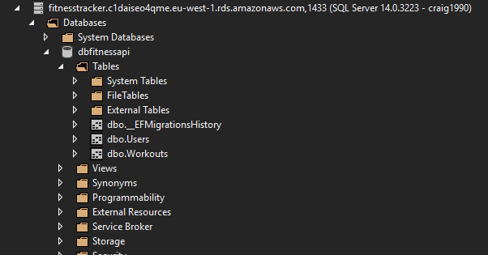

Database is hosted on AWS RDS

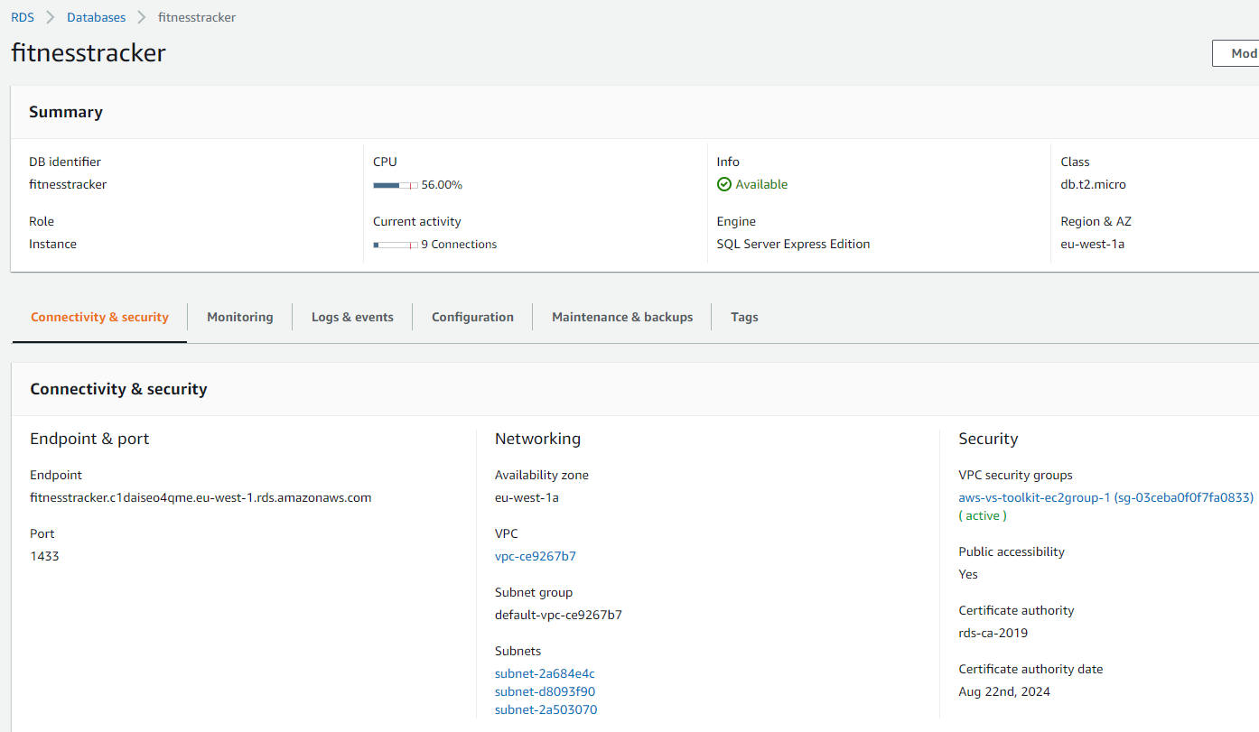

RESTful web service is hosted on AWS Elastic Beanstalk via an Azure DevOps pipeline which runs our unit tests and static code analysis.

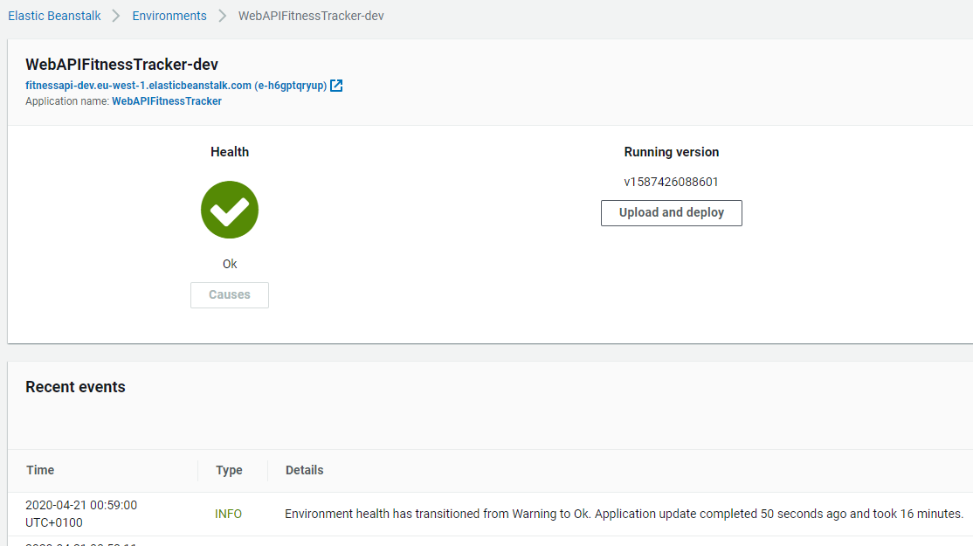

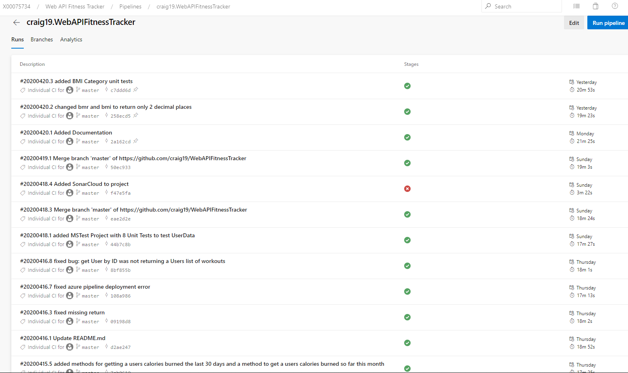

Full .yml file available on web API Git repo

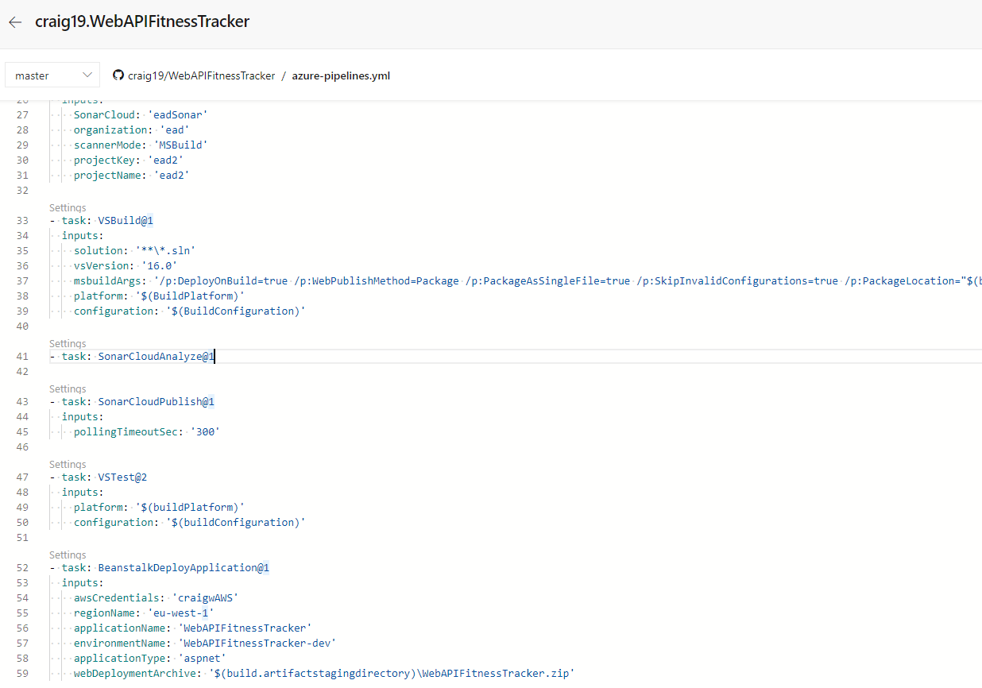

GitHib has been fully utilized. All commits to the Web API repo kick-off an Azure pipeline build which analyses our code with SonarCloud and runs our unit tests. If these unit tests pass it will deploy to our development env on AWS Elastic Beanstalk.

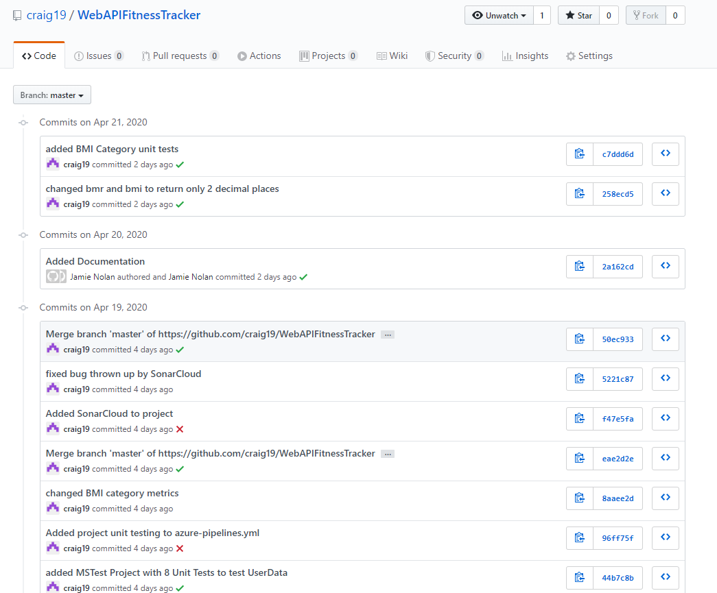

Unit tests (full list available on web API Git repo)

